

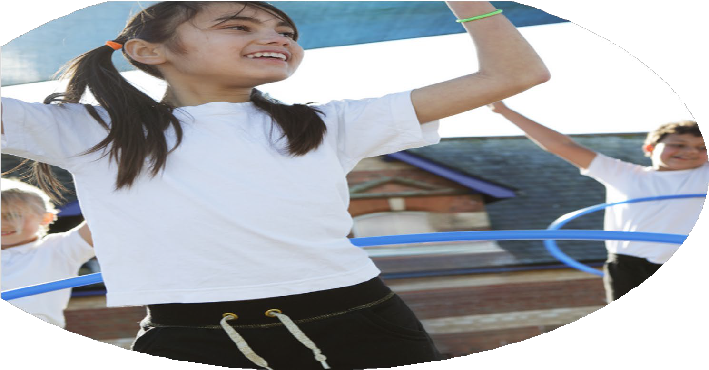
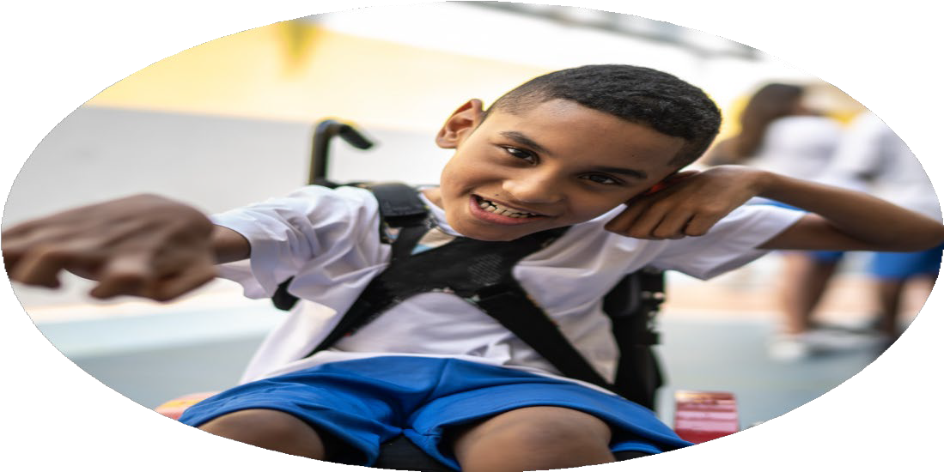




PE Funding

Evaluation Form

Commissioned by

Created by

Images courtesy of Youth Sport Trust

PE Funding Evaluation Form

It is intended that this template should be used as preparation for the completion of the statutory digital reporting tool being introduced this academic year. You can upload data (including swimming) from this template onto this platform once it becomes accessible.
Before you decide how you are going to use the funding for this academic year you should reflect and evaluate the impact of your use of the funding in 2023/24.
All spending of the funding must conform with the terms outlined in the Conditions of Grant document. The template is a working document that you can amend/update during the year.
Based on your evaluation of last year’s funding you should decide what you intend to do this academic year, how you will do it, and what impact you expect it to have.

It is important that the funding is used effectively and based on your school’s needs.
You must use the funding to make additional and sustainable improvements to the PE and sport in your school. You must develop and add to the PESSPA activities that your school already offers.

Summative digital reporting from June 2025 will continue to include swimming and water safety information therefore funding can be used to provide top-up lessons where necessary to ensure pupils meet national curriculum swimming requirements.

We recommend that you start by reflecting on the impact of current provision and reviewing your previous spend

What went well? | How do you know? | What didn’t go well? | How do you know?
Enhanced Facilities and Resources  The school benefited from access to high-quality facilities, including the Football Factory and indoor 3G pitches, which significantly enhanced the physical education (PE) experience for pupils.  High-Quality Coaching and CPD  Continued investment in specialist coaches and professional development (CPD) ensured that staff were well-equipped to deliver engaging and effective PE lessons. This ongoing support has strengthened staff confidence and competence in delivering a broader PE curriculum.  Lunchtime Sporting Activities  Staff training enabled the successful implementation of structured lunchtime sporting activities, increasing daily physical activity and engagement for pupils across all key stages.  Mentoring Facility Completed  The completion of a dedicated Mentoring Facility provided a valuable space for targeted support and development, contributing to both physical and personal growth for pupils.  Wider Competition Participation  pils had increased opportunities to participate in both local and Trust competitions, catering to all levels of ability. This inclusive approach supported the development of teamwork, resilience, and sportsmanship.  Specialist Mentoring for EYFS and KS1  Targeted specialist mentoring for staff in EYFS and KS1 further strengthened early years provision, equipping teachers with the tools and confidence to deliver high-quality physical development activities from the outset of school life. | The impact of the Sports Premium can be clearly seen through a range of evidence and outcomes across the school. Access to high-quality facilities, including the Football Factory and indoor 3G pitches, has provided year-round opportunities for children to engage in sport, regardless of the weather. The introduction of specialist coaching and mentoring has strengthened our provision, not only enhancing pupil performance but also significantly improving staff confidence and competence in delivering high-quality PE. Teachers and teaching assistants, particularly in EYFS and KS1, have received targeted support, allowing them to develop their skills and feel more equipped to deliver engaging and effective lessons.  Structured lunchtime sporting activities have led to a noticeable reduction in poor behaviour during unstructured times, with pupils more actively engaged and positively occupied. Children have taken part in a range of physical activities they may not have previously considered or felt confident to try, leading to increased participation and enjoyment across all year groups. Our PE curriculum supports the development of fundamental movement skills, and children are demonstrating clear progress in their physical development. Staff and pupils alike are accessing a rich curriculum that enables children to become secure in their learning and grow in confidence.  Participation in local and trust-wide competitive sports has also grown, with pupils gaining valuable experience in representing the school and developing key attributes such as teamwork, resilience and sportsmanship. These opportunities are not only building confidence but also supporting children in preparing for the transition to secondary school, where such experiences will serve them well. Evidence published on our website shows we are improving as a school due to our continued investment and commitment to sport. More pupils are now qualifying for national events and we are achieving increasing success in competitions outside of school. While staff confidence has improved, we recognise that ongoing professional development will remain a key focus to maintain momentum and continue raising standards. | Despite targeted efforts, we continue to face challenges in increasing the number of pupil premium (PP) children accessing after-school sports provision. Although these activities have been offered free of charge and aimed specifically at identified pupils, uptake has remained limited. Various strategies have been trialled to improve engagement, but the impact has so far been minimal, and this remains an area requiring further attention and innovation.  In addition, plans to introduce on-site swimming provision using portable pools had to be withdrawn following advice from the local authority regarding health and safety concerns. While this initiative had the potential to provide additional swimming opportunities for pupils, particularly those who may struggle to access lessons off-site, we were unable to proceed due to the risk assessments and safeguarding guidance provided. | Swimming did not take place during this academic year due to the withdrawal of our planned on-site provision. As a result, pupils missed the opportunity to engage in swimming lessons during term time. We are committed to addressing this by providing catch-up opportunities in future years to ensure all children meet national curriculum requirements for swimming.  Despite making after-school clubs free and targeting specific groups, the number of disadvantaged pupils attending has only increased marginally. Participation data and attendance records show limited uptake from pupil premium children, indicating that current strategies have not had the desired impact. This continues to be a key area for development moving forward.

What are your plans for 2024/25? | How are you going to action and achieve these plans?
Intent | Implementation
In 2024–25, we aim to expand and embed high-quality physical activity opportunities throughout the school day, with a focus on improving engagement, access, and sustainability. Our priorities include the further development of break and lunchtime sporting activities led by trained staff, including teaching staff, lunchtime supervisors, and specialist coaches. These activities will be designed to ensure all pupils, including those who are less active or reluctant, can participate regularly and confidently.  We will continue to invest in high-quality CPD for staff, including bespoke mentoring for EYFS and KS1 teachers, to ensure high-quality delivery of PE across all phases. The Football Factory partnership will be sustained to provide access to elite facilities and coaching. Our mentoring facility will support structured development of pupils’ personal and physical skills.  In addition, we will provide a catch-up swimming programme to compensate for the missed provision this academic year, ensuring that children still meet national curriculum swimming requirements. Finally, we aim to increase the number of disadvantaged pupils accessing after-school sport, recognising this as a key area for improvement. | Provide targeted CPD and mentoring for teaching staff and teaching assistants, focusing on key areas such as delivering active lessons, inclusive PE, and leading lunchtime sport.  Train lunchtime supervisors and support staff to confidently lead structured physical activities, ensuring they are safe, engaging, and inclusive for all pupils.  Continue to use external coaches (e.g. through the Football Factory partnership) to enhance curriculum and enrichment opportunities.  Further develop the Mentoring Facility as a space to support social, emotional, and physical wellbeing through sport.  Launch a catch-up swimming programme, working with local facilities and prioritising pupils who missed lessons due to cancelled provision in the previous year.  Introduce targeted strategies to increase the uptake of after-school clubs by disadvantaged pupils. This may include pupil voice surveys, parental engagement, personalised invites, and identifying/removing participation barriers.  Maintain strong links with local and trust competitions, ensuring inclusive entry for all abilities.

What impact/intended impact/sustainability are you  expecting? | How will you know? What evidence do you have or  expect to have?
We expect to see increased engagement in physical activity across the school day, particularly at lunchtimes and among children who are currently less active. Staff will be more confident and better equipped to deliver high-quality PE lessons and lead physical activity outside of curriculum time.  Disadvantaged pupils will be more engaged with sport and active clubs, leading to improved wellbeing, behaviour, and overall participation. Our investment in staff training, mentoring, and sustainable lunchtime models will allow this provision to continue and grow even with reduced external support in the future.  Catch-up swimming will ensure children do not fall behind national curriculum requirements, and our structured use of facilities and competitions will continue to raise the profile of PE and sport across the school. | Attendance data for after-school clubs, with particular attention to disadvantaged pupils  Staff CPD evaluations, including self-assessment surveys and mentor feedback  Pupil surveys on enjoyment, confidence, and perceived competence in sport and physical activity  PE lesson observations and learning walks showing increased teacher confidence and pupil engagement  Swimming data to track progress toward meeting national curriculum standards  Competition participation records, including inclusion of pupils at different ability levels

What impact/sustainability have you seen? | What evidence do you have?
We have seen increased participation in competitions and enrichment activities, and our PE curriculum is now broader and more ambitious, supporting a wider range of physical and personal development goals.  This progress aligns with our key aims:  - Increased confidence, knowledge, and skills of all staff in teaching PE and sport  - Greater engagement of all pupils in regular physical activity  - A raised profile of PE and sport as a driver of whole-school improvement  - A broader range of sports and activities offered to all pupils  - Increased participation in competitive sport | Our evidence includes pupil and staff surveys, CPD evaluation forms, competition entry and achievement records, club attendance registers (including PP tracking), and swimming assessment data. These collectively demonstrate our ongoing improvement and areas for targeted development in 2024–25.

