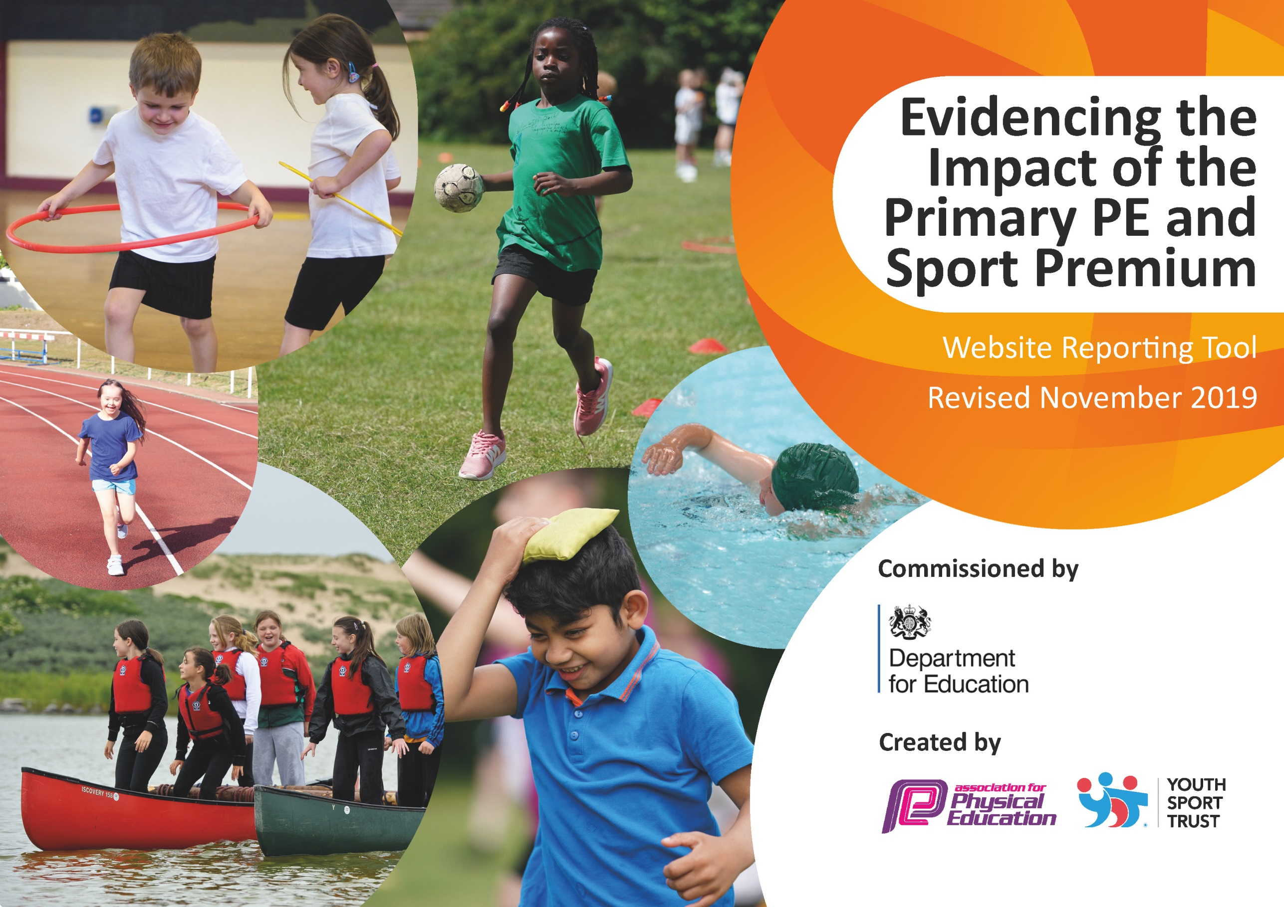
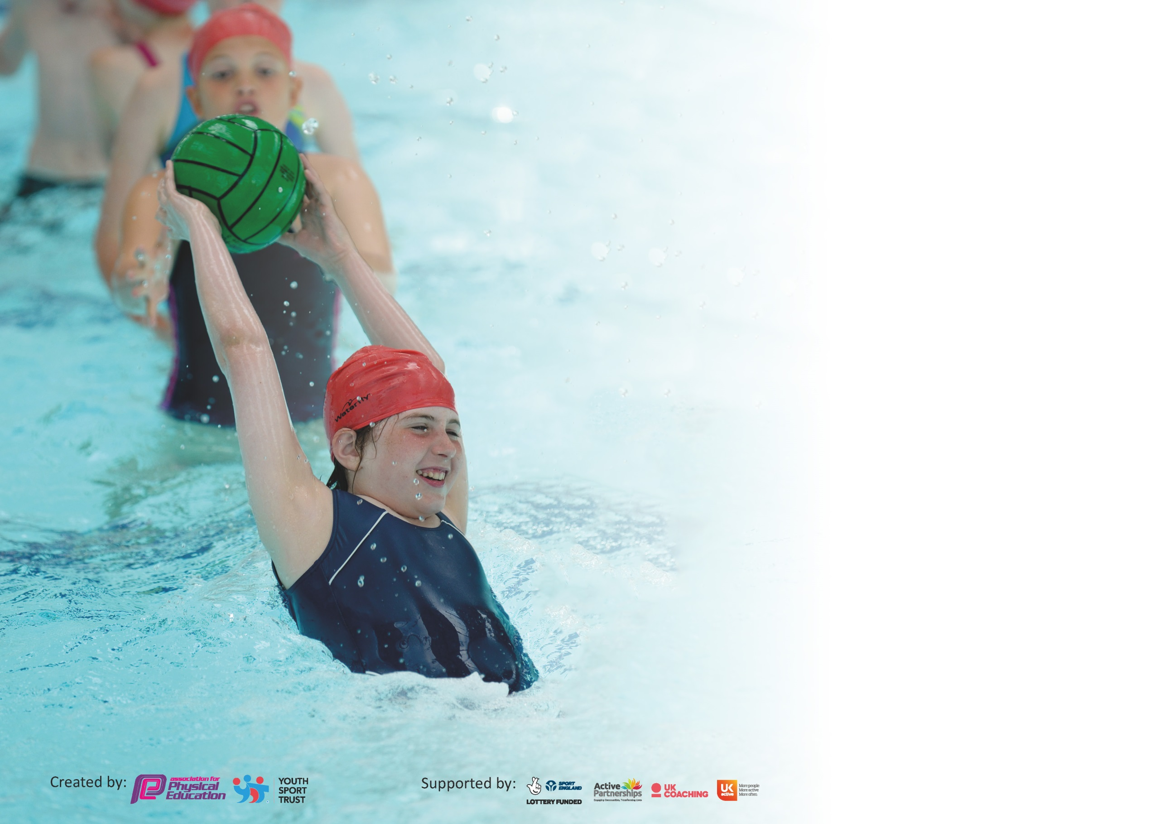

It is important that your grant is used effectively and based on school need. The Education Inspection Framework (Ofsted 2019 p64) makes clear there will be a focus on ‘whether leaders and those responsible for governors all understand their respective roles and perform these in a way that enhances the effectiveness of the school’.

Under the Quality of Education criteria (p41) inspectors consider the extent to which schools can articulate their curriculum (INTENT), construct their curriculum (IMPLEMENTATION) and demonstrate the outcomes which result (IMPACT).

To assist schools with common transferable language this template has been developed to utilise the same three headings which should make your plans easily transferable between working documents.

Schools must use the funding to make additional and sustainable improvements to the quality of Physical Education, School Sport and Physical Activity (PESSPA) they offer. This means that you should
use the Primary PE and Sport Premium to:

- Develop or add to the PESSPA activities that your school already offer
- Build capacity and capability within the school to ensure that improvements made now will benefit pupils joining the school in future years

Please visit gov.uk for the revised DfE guidance including the 5 key indicators across which schools should demonstrate an improvement. This document will help you to review your provision and to report your spend. DfE encourages schools to use this template as an effective way of meeting the reporting requirements of the Primary PE and Sport Premium.

We recommend you start by reflecting on the impact of current provision and reviewing the previous spend.

Schools are required to publish details of how they spend this funding as well as on the impact it has on pupils’ PE and sport participation and attainment by the end of the summer term or by 31st July 2020 at the latest.

We recommend regularly updating the table and publishing it on your website throughout the year. This evidences your ongoing self-evaluation of how you are using the funding to secure maximum, sustainable impact. Final copy must be posted on your website by the end of the academic year and no later than the 31st July 2020. To see an example of how to complete the table please click HERE.

Support for review and reflection - considering the 5 key indicators from DfE, what development needs are a priority for your setting and your pupils now and why? Use the space below to reflect on previous spend and key achievements and areas for development.

Key achievements to date until July 2019: | Areas for further improvement and baseline evidence of need:
New Curriculum leader of PE establishing roles and responsibilities.  Playground equipment to promote regular exercise.  Offer afterschool clubs.  Developed CPD in specific areas – KS1 (gymnastics, tag rugby, tennis, hockey, kinetics), KS2 (football, athletics, fitness/circuits)  Raised profile of sport through Tour de Yorkshire and GB athletes | Main PE targets;  Additional swimming provision for children who cannot swim 25m after Y4.  Swimming CPD.  Take part in a greater number of the Five Towns Primary School Games Opportunities.  Introduce more intra school sporting competitions.  PE lead CPD.  Additional PE targets;  Provide a wider range of afterschool clubs based on pupil voice/parent voice.  Continue to broaden curriculum offered through coaches and CPD.  Ensure more year groups are involved in regular exercise e.g. go noodle/active mile.  Better promote parkrun  Create PE display with colour teams.

Meeting national curriculum requirements for swimming and water safety.
What percentage of your current Year 6 cohort swim competently, confidently and proficiently over a distance of at least 25 metres?  N.B. Even though your pupils may swim in another year please report on their attainment on leaving  primary school at the end of the summer term 2020. | 27/40  67.5%  No data for children who weren’t with us in Year 4 – 3 pupils
What percentage of your current Year 6 cohort use a range of strokes effectively [for example, front crawl, backstroke and breaststroke]? | 8/40  20%
What percentage of your current Year 6 cohort perform safe self-rescue in different water-based situations? | 8/40  20%
Schools can choose to use the Primary PE and Sport Premium to provide additional provision for swimming but this must be for activity over and above the national curriculum requirements. Have you used it in this way? | Yes/No  Yes for Year 6 w/c 24.02.20

Action Plan and Budget Tracking
Capture your intended annual spend against the 5 key indicators. Clarify the success criteria and evidence of impact that you intend to measure to evaluate for pupils today and for the future.

Academic Year: 2019/20 | Total fund allocated: £18,700  Spent: £18,500  Carry over: £200 | Date Updated: 15.07.20
Key indicator 1: The engagement of all pupils in regular physical activity – Chief Medical Officer guidelines recommend that primary school pupils undertake at least 30 minutes of physical activity a day in school |  |  |  | Percentage of total allocation:
 |  |  |  | 11.5%
Intent | Implementation |  | Impact
Your school focus should be clear what you want the pupils to know and be able to do and about  what they need to learn and to  consolidate through practice: | Make sure your actions to achieve are linked to your intentions: | Funding allocated: | Evidence of impact: what do pupils now know and what can they now do? What has changed?: | Sustainability and suggested next steps:
Ensure all children have at least 30 minutes exercise per day in line with recommendations. | Elect play leaders in school (UKS2) and look into Play Maker programme to develop sports leadership skills and help support provision at lunchtime.  Junior Leadership Team (JLT) to review physical activity levels at break and lunchtime and develop ideas for provision and the 30 minute strategy. | £99 carry over to next year | N/A | Elect head and deputy head play ambassadors for physical activity at the beginning of the year and meet to discuss how play leaders could work during COVID (social distancing).  Look into buying Play Maker programme.
Target inactive children by offering lunchtime and after school clubs. | Identify the children and ensure they take part in daily physical activity. | No Cost | Inactive children throughout school have been identified by class teachers and children are subtly but actively encouraged /supported to join in being active; in the classroom via brain breaks, on the playground, during physical education lessons. | Ensure new teachers are aware of inactive children they may be getting and continue to encourage them to take part in the physical activity previously stated.
Increase activity level at lunchtimes through the introduction of play leaders running lunchtime activities for both KS1 and KS2. | To ensure there is a variety of activities and equipment available. | No Cost | Sports Ambassadors established. Need to elect several play leaders to man physical activity stations at lunch and playtime. KS2 pupils who would otherwise not be taking part in physical activity are now joining in and helping younger children and modelling how to play games or gain skills such as skipping. | Discuss how play leaders could work with COVID restrictions and children not being able to cross bubbles.
Replenish and purchase equipment and resources for physical activity and after school clubs. | To ensure that there is a variety of equipment and resources available. | Net ball pitch - £250  KS2 Mini football pitch - £250  KS1 Mini football pitch - £250  Copy me game - £250  Outdoor snakes and ladders game - £250  Physical activity equipment - £500 | Junior Leadership Team to carry out audit of physical activity equipment that needs to be ordered. Additional playground equipment to help play leaders and encourage all children to be active was ordered. The combination of play leaders plus extra equipment made activity levels at break and lunch times 15% higher as recorded by play ambassadors.  Junior Leadership Team carrying out survey to find out what children believe are the most sustainable playground resources and equipment. Children identified playground markings and football and netball goals as their priorities for enabling and sustaining playground activity.  Pitches and KS1 games playground markings organised to be put down over summer holidays. | Audits and pupil voice will continue to be the driving force for new physical activity equipment.
Encourage all staff to deliver and support sport/activity clubs. | Staff dedicate time to staying after school including HLTAs and TAs. | TAs - £400 | TAs dedicated time to both one half term of tag rugby and two half terms of cheerleading/dance.  1-1 SEN Assistant supporting Multi-Sports for inclusion of SEND pupils. | Staff continue to offer after school clubs.
Offer additional swimming lessons to those children who have not achieved the NC requirement in Y4 | Liaise with Pontefract Leisure Centre to organise logistics. Letter to parents offering additional lessons. Measure the impact | £500 carry over to next year. | 10 Year 6 pupils have had letters sent home to help them achieve KS2 expectations. Swimming booster sessions set to start 24.02.20. | Children began top up lessons but due to COVID – 19 this only happened for a few weeks.
Offer a range of sports and activities during sports week. | Organise coaches and teachers to deliver a range of activities over the week. | £600 carry over to next year | Still TBC  Look into dance organisation Young Voices children expressed interest in. | Sports week activities to be organised for next year.
Include balancability on the LTP for PE. | Continue to liaise with Cycle North about sessions they offer. | FREE | Year 1 and Year 2 participated in balancability. All children expressed great excitement in taking part. One child felt reluctant to try and lacked a lot of confidence yet by the end of the sessions was very confident and even went home to carry on practising riding her own bike. There was a lot of feedback from parents saying it had inspired their children to continue learning to ride their bikes at home and in many cases master how to ride a bike without stabilisers. | Get in touch with cycle North to see if they have funding for next year.  This will need to be paid for if funding is not available.
To take part in events to increase physical activity | Sports Relief  Around the World – Forget me not Hospice | FREE | St Giles take over Pontefract Parkrun Sunday 8th March to kick start Sports Relief week. Sports Relief coincides with Science week. Could children measure effects on body from physical activity. Other idea classes set themselves 1 physical challenge each to complete within the week. | Continue to encourage children to take part in free local activities such as parkrun (keep an eye on when this restarts).
Take part in additional PE programmes offered to school. | PE influencers offer free day of PE through their company’s sponsorships. | FREE | Additional PE sessions will be delivered to KS1 children 03.04.20. In area of sport not offered on our LTP. | Didn’t take place due to lockdown.
Key indicator 2: The profile of PESSPA being raised across the school as a tool for whole school improvement |  |  |  | Percentage of total allocation:
 |  |  |  | 19%
Intent | Implementation |  | Impact
Your school focus should be clear what you want the pupils to know and be able to do and about  what they need to learn and to  consolidate through practice: | Make sure your actions to achieve are linked to your intentions: | Funding allocated: | Evidence of impact: what do pupils now know and what can they now do? What has changed?: | Sustainability and suggested next steps:
Use physical activity and sport as a context for developing children’s character, leadership and social and emotional skills.  Promote positive children’s mental health through engagement in physical activity and sport. | Forrest school programme to be implemented to support the development of learning skills and attributes through physical activity. LKS2 staff to be trained in the programme which will also be used to target social, emotional and behavioural intervention programmes e.g. team work, resilience, confidence etc. | £3600 | Class 3 and 3-4 have completed a term of Forrest School lessons 1-per-week. Pupil Voice/work produced for Class 3-4 Assembly on Forrest schools shows the positive impact the sessions have had on their team-work, communication and confidence skills. The following term will see a further 2 classes take part in Forrest school. | Forrest school has proven beneficial for KS2 children for a number of reasons including, team work, communication, physical activity, food and cooking.  Look into the schools stance on having Forrest school staff in school with new COVID guidance,
Celebrate sporting achievements across school. | Children to receive trophies/medals/certificates for events they participate in. | Supplied by competitions.
Promote positive sporting attributes by focusing on an attribute each day during sport’s week. | Ensure everyone is aware of 5 sporting attributes for sports week. | No Cost | Didn’t take part place due to COVID. | Carry over to next year.
Park Run | Enter/register our school. Letters to parents with registration info. Celebrate results in assembly and share results with teachers and classes via email. | FREE | Registration from last year still valid. Confirmed interest in being included in this year’s junior parkrun competition. Letters sent home to children interested. Dojo message to all parents. 11 children completed the first event 9 of which were newly registered. Celebrated with certificates in assembly. 2 more events cancelled due to storms.  Ended up being cancelled due to COVID. | Continue to take part in parkrun competitions next year.
Take part in National Sports Week to raise the profile and increase club links | Organise coaches/specialist staff to lead sports activities. Introduce children to new/different sports. Make club links. |  |  | Carry over to next year.
PE Co-ordinator to assess and monitor teaching and learning of PE across the school. | Questionnaire Informal lessons observations. Lesson support and guidance with planning. | No Cost | LTP tweaked to include areas of sport and PE taught by A1 and Total coaches ensuring curriculum coverage. | Liaise with staff about how PE will look next year. Discussing social distancing physical education opportunities and the types of equipment we could use. This will mean changing the PE LTP.
Sports Ambassadors on Junior Leadership Team – to allow children to have a voice about PE, physical activity and sport in school. | Appoint Sports Ambassadors. Carry out questionnaire across school regarding playground equipment and physical activity. | No Cost | Year 6 Sports Ambassadors identified and have shared pupils’ voice on playground equipment from this quotes for playground markings have begun. | Continue to monitor and develop physical activity opportunities for children and needs for the playground.
PE Prompts/ posters displayed in the hall. | Update and adapt PE displays continuously. | No Cost | No display as of yet. Ideas include; PE values, outside afterschool club pics + in house ones, competitions, festivals and curriculum PE pics (forest school, half termly competitions, balancability/bikeabilty etc.)  Photographs of extra-curricular activities are displayed in school. | PE Values need to be displayed in the hall. Plus brainstorm other necessary PE display ideas e.g. nutrition, warm up, cool down, out of school physical activity photographs.

Key indicator 3: Increased confidence, knowledge and skills of all staff in teaching PE and sport |  |  |  | Percentage of total allocation:
 |  |  |  | 57%
Intent | Implementation |  | Impact
Your school focus should be clear | Make sure your actions to | Funding | Evidence of impact: what do | Sustainability and suggested
what you want the pupils to know | achieve are linked to your | allocated: | pupils now know and what | next steps:
and be able to do and about | intentions: |  | can they now do? What has
what they need to learn and to |  |  | changed?:
consolidate through practice:
PE Coordinator CPD | PE leader to attend conferences led by local authority. | £50 | PE lead attended Conference at Waterton Park Hotel important points from the day included; the jobs that the role encompasses and how to prioritize them, the importance of physical activity on mental health and how to document funding. | Check dates for PE conference for next year and book on.
Competitive Sport CPD | Total Coaches work with Curriculum lead to develop a bespoke curriculum for KS1 pupils.  A1 Coaches work alongside KS2 staff to develop confidence to deliver competitive intraschool competitions. | £4900  £5700 | Coaches worked with PE Curriculum Leader to offer a PE Curriculum that builds skills leading to competitive games of sport each half-term. Teachers’ confidence in delivering PE lessons that build skills and their understanding of skill progression in different sports has increased. The percentage of physical activity each lesson due to competition has increased. | Next year we have taken the decision to not use coaches initially. Teachers will take what they have learnt from coaches and provide a curriculum based on sportsmanship and competition at the end of units.
Key indicator 4: Broader experience of a range of sports and activities offered to all pupils |  |  |  | Percentage of total allocation:
 |  |  |  | 11%
Intent | Implementation |  | Impact
Your school focus should be clear | Make sure your actions to | Funding | Evidence of impact: what do | Sustainability and suggested
what you want the pupils to know | achieve are linked to your | allocated: | pupils now know and what | next steps:
and be able to do and about | intentions: |  | can they now do? What has
what they need to learn and to |  |  | changed?:
consolidate through practice:
Additional achievements;  Ensure that pupils have basic cycling skills and knowledge of road safety linked to cycling. | Balancability sessions for all Year 2 pupils and Bikeability sessions for all Year 6 pupils (one week in Autumn) | FREE | All year 2 pupils took part in balancability where by at the end of the week all children could practise on a 2-wheeled bike with no stabilizers. All Year 6 pupils took part in bikeability sessions where by at the end of the week children who were deemed safe to ride on the road were taken out on the road. Certificates were awarded to all students in assembly. Following this Year 1 pupils are due to take part in balacability w.c. 24.02.20. Completed. KS2 Non- riders have been identified for a days intervention (06.03.20). Completed. | Year 6 bikeability has been booked for next year. Waiting to hear back about funding for Year 2 balancability if not it will be paid for.
Ensure that pupils leave school with basic water safety skills and feel confident in water and are able to perform safe self-rescue in different water-based situations. | Booster swimming sessions for Year 6 pupils on a weekly basis (Spring Term and Summer Term). | See previous;  £500 | See previous;  10 Year 6 pupils have had letters sent home to help them achieve KS2 expectations. Swimming booster sessions set to start 24.02.20. | Began but never completed as above.
Provide pupils with a high-quality curriculum led by qualified sports coaches. | Multi-Sport sessions for Nursery-Year 2 (1 session a week).  KS2 pupils attend A1 football factory (one session a week) on a sporting curriculum developed by coaches. | See previous | See previous | See previous
Enhance opportunities after school where pupils can access physical activities. | Football Factory and Multi-Sport coach offer after school clubs.  Staff to provide additional after school clubs throughout the year. | £1100  £1000 | Mulitsports – KS1  Football – KS2  Cheerleading – All  Tag Rugby – KS2 | With no coaches in school next year afterschool clubs will rely on teachers/teaching assistants to carry them out.
Enhance opportunities at break and lunch time where pupils can access physical activities independently and those led by peers. | Via play leaders. | See previous | See previous | See previous
Provide pupils with adequate PE resources in order to achieve National Curriculum PE outcomes. | Do audit and purchase any equipment needed to deliver PE successfully. | £3000 – carry over to next year | All staff were asked at the end of the year what equipment would need to be ordered to carry out PE lessons next year considering new guidance. | Order equipment including some for sports we currently don’t have.

Key indicator 5: Increased participation in competitive sport |  |  |  | Percentage of total allocation:
 |  |  |  | 0%
Intent | Implementation |  | Impact
Your school focus should be clear | Make sure your actions to | Funding | Evidence of impact: what do | Sustainability and suggested
what you want the pupils to know | achieve are linked to your | allocated: | pupils now know and what | next steps:
and be able to do and about | intentions: |  | can they now do? What has
what they need to learn and to |  |  | changed?:
consolidate through practice:
Develop more competitive intraschool sports opportunities and games. | Intraschool competitive games to win points for PE colour team. (PE display board) | No Cost | End of half tem competitive games only occurred once before lockdown.  As school doesn’t use colours often in school it wasn’t as rewarding. | Think about displaying winning teams at the end of half termly competitions.
PE lead to find out more about the New Trusts cluster competitions. | Get in touch with schools in trust. | No Cost | Carry over to next year.
Enter competitions and festivals that Five Towns Games Opportunities offer. | Tag Rugby Tournament x2  Cross country competition | No Cost | Children took part in 3 out of school competitions giving them experience in what it feels like to represent your school and be part of a team. | Look at what and if competitions are taking place next year.

Signed off by
Head Teacher: | R.Grace
Date: | 15.07.20
Subject Leader: | K.Best
Date: | 15.07.20
Governor: | B. Groves
Date: | 15.07.20

